The Martin Luther High School Drama Department presents:
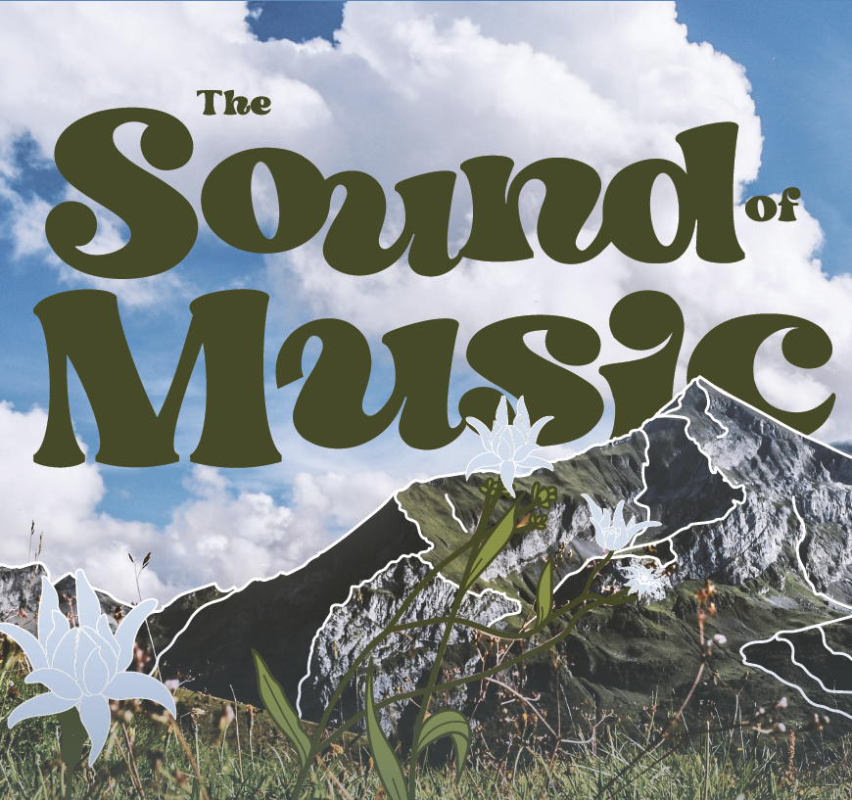

The Sound of Music is a tuneful, heartwarming story based on the real-life story of the Von Trapp Family singers, one of the world's best-known concert groups in the era immediately preceding World War II. Maria is a tomboyish postulant at an Austrian abbey who becomes a governess in the home of a widowed naval captain with seven children and brings a new love of life and music into the home.

Friday and Saturday, November 10 & 11 at 7:00 p.m.
Sunday, November 12 at 2:00 p.m.

Numbers of Tickets

Reserved Center & Wing Fri., Nov. 10 Sat., Nov. 11 Sun., Nov. 12
Assigned Seats 7:00 pm 7:00 pm 2:00 pm

Adults $10.00

Senior Citizen & K-12
ML Staff & Students
LHSAGM Passes $5.00

General Admission Side
Unassigned Seats

Adults $6.00

Senior Citizen & K-12 $4.00

ML Staff & Students
LHSAGM Passes Free

Name
Please bring or send your order to:

Martin Luther High School

C/O Mrs. Lisa Kamprath
5201 South 76th Street
Greendale WI 53129
Email
Phone Student

Reserved seating: wheelchair or walker Details:
(Circle one)

Phone orders not accepted. Credit card payments can be accepted at the door. Place your order early by direct mail, through your student, or by email (lkamprath@martinlutherhs.org). Payment (cash or check only) must accompany your order. If you choose to pay by credit card, tickets will be held for you at the door, or you may enclose a self-addressed, stamped envelope for return, or you may pick them up in the office between the hours of 7:30 A.M. and 4:00 P.M.

You may also have your student pick up the tickets from Mrs. Kamprath.

