The Martin Luther High School Music Department Presents:
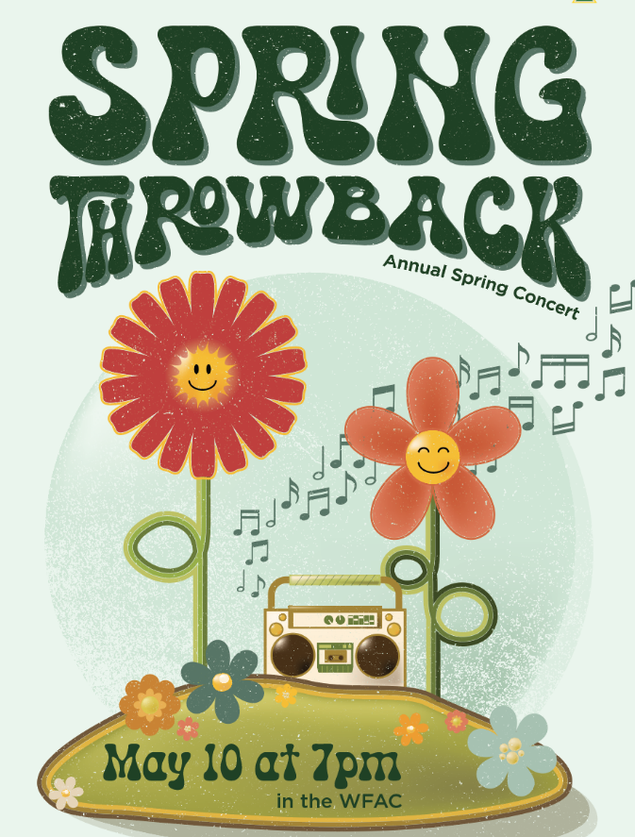

Reserved Assigned Seats: (center & wing)

Adults $10.00

Seniors (60), K-12,
ML Staff & Students,
LHSAGM Passes $5.00

General Admission: (unassigned side)

Adults $6.00

Seniors (60) and K-12 $4.00

ML Staff & Students
LHSAGM Passes FREE

----------------------------------------------------------------------------------------------------------------------------------------------------------------------------------------------------------------------------------------------------------------------------
Ticket order form:

Reserved adult: # __________ x $10 = __________
Reserved senior, ML staff/student, LHSAGM pass: # __________ x $5 = __________

General admission adult: # __________ x $6 = __________
General admission senior & non-ML K-12 # __________ x $4 = __________
General admission ML staff/student or LHSAGM pass: # __________ x $0 = FREE

Name: _____
Bring or send your order to:

Martin Luther High School
c/o Mrs. Lisa Kamprath
5201 South 76th Street
Greendale, WI 53129

E-mail: _____

Phone: _____

Student: ___________________________________________

Special seating (reserved only): wheelchair or walker (circle one)

Details:

Phone orders not accepted. Place your order early by direct mail, through your student, or by email (lkamprath@martinlutherhs.org). Payment (cash or check only) must accompany your order. Credit/debit cards will be accepted at the door. Tickets will be held for you at will call, or you may pick them up in the office between the hours of 7:30 A.M. and 4:00 P.M. You may also have your student pick up the tickets from Mrs. Kamprath.

